Chapter 1
INRODUCTION
Image to speech conversion is a trending aspect of computer technology. It determines an important criterion in which we interact with the system and interfaces across a variety of platforms. Machine replication of human functions, like reading, is an ancient dream. However, over the last five decades, machine reading has grown from a dream to reality. Speech is probably the most efficient medium for communication between humans. Optical character recognition has become one of the most successful applications of technology in the field of pattern recognition and artificial intelligence.

1.1 Motivation
According to survey in 2012, blind or visually impaired people represent 1.5 per cent of the Indian population. A large number of people suffer from the same globally. Most of their vision related troubles do not allow them to have access to textual information. Reading is undoubtedly of utmost importance for daily independent working since text is present everywhere - either under the form of documents(newspapers, books, mails, magazines, commercial product’s label) or text in natural scenes (signs, screen, schedules). There have been various attempts made to give them access to most of the information. However these attempts do not solve the problem perfectly. For example, text can be zoomed but optical enhancement is cumbersome or information can be translated in Braille but it is requires complex learning and, by fact, most visually challenged people cannot read in Braille.
In the early 60s, optical character recognition was the prime applications of pattern recognition, and today, for some simple tasks with clean and well-formed data, document analysis is viewed as a solved problem. However this does not represent the common need of document image analysis.
In today’s world we are experiencing an increase in the availability of cheaper and portable imaging device exhibiting high performance. Not only that, they are easily integrated with other networks. This is rapidly supplementing traditional scanning for document image acquisition. Markets provide digital cameras attached to cell phones, PDAs and other standalone still or video devices which are highly mobile and simple to use. They are useful in capturing images of any kind of document including thick books, historical pages too fragile to touch, and text embedded in scenes. These imaging devices have proved to be more versatile than desktop scanners.
With this trend of digital imaging the need to extraction of text from images has also been recognized. For instance, consider you wish to exercise for an hour but you also have to finish reading a book for an assignment in college. Or, consider you have to drive to work but you wish to read the newspaper at the same time. If there is an application that can read it out for you, you can multitask!
These advantages of digital imaging are increasing demand of the document processing community where cameras are used to image printed documents, or natural scenes containing textual data. The challenges of complex content and layout, noisy data and variations in font and style presentation still persist. Work in the field covers many different areas including pre-processing, physical and logical layout analysis, optical and intelligent character recognition (OCR/ICR), graphics analysis, form processing, signature verification and writer identification, and has been applied in numerous domains, including office automation, forensics, and digital libraries.
In India almost all children are bilingual. Apart from the mother tongue they should be able to communicate fairly in English too. It may be difficult for them to learn the language and correct pronunciations with little guidance. An application which helps children learn pronunciations as well as spellings and meanings can prove to be helpful. If a soft copy of their favourite books is available, an application that is able to read it along with them can solve the problem.
For those who are just learning the language, it might be challenging to understand road signs and signals or reading addresses and letters etc. There should be a way to help them read and understand the same. One may simply click a picture of the material and it could be read out to them. Not only that, difficult word meanings should also be available at all times. Such an application will clearly prove to be very helpful.

1.2 Existing Applications verses SeeTell
Attempts were made to build machines to create human speech way before electronic signal processing existed. Initial availability of speaking machines includes Albertus Magnus (1198-1280),Gerbert of Aurillac(d.1003 AD), and Roger Bacon (1214- 1294). The first computer based speech synthesisers came into existence as late as the 1950s. The first functional text-to-speech system was completed in 1968. The first successful prototype for reading machine was developed by the Haskin Laboratories in the 1970s. These large prototypes were used to send the output from a fixed font OCR to the input of speech synthesis algorithm which was developed at Haskin Laboratories.
The text reciting systems which are already in existence for helping the visually impaired people are ‘I-Scan’, ‘Kurzweil 1000’, ‘Cicero text reader’, ‘Open Book’, ‘Ovation’, ‘Scan N Talk’, ‘VERA’etc. Nonetheless, all these systems are very expensive and cost more than 2 lakh INR. Intel announced the launch of a Linux based text reading device by the end of 2009. It included optical character recognition and text-to-speech technology. This system was valued at nearly 80,000 INR. Another text reader called ‘Optelec Clear Reader+ Advanced’ had also been introduced in 2010. It included a reading assistant which can scan, view, magnify, save and listen to any printed document in one portable solution. Again, this system was estimated to cost over 1lakh INR.
The early electronic speech synthesizers sounded mechanical and were often minimally intelligible. However, the quality of generated synthesized speech has gradually improved over the time, but output from contemporary speech synthesis systems is still not even closely like actual human speech. There are systems used for text recognition that are limited by requiring user assistance or due to the fact that they are expensive. These existing systems also use specific shapes or colour masks which is not preferable to rely on. Therefore there is a requirement for cheaper systems that will be able to automatically find regions of an image containing text and recite the text clearly to visually impaired persons.
The industry has sensed the preference of camera over scanners, and is shifting some of the scanner-based OCR applications onto new platforms. For example, XEROX has a Desktop PC-cam OCR suite, based on their CamWorksproject, aimed at replacing scanners with PC-cams in light workload environments. The ‘DigitalDesk’project turns the desktop into a digital working area through the use of cameras and projectors. Other applications are being enabled as well, such as intelligent digital cameras to recognize and translate signs written in foreign languages. Currently most research is focused on processing single images of text, but as technology advances text from video will be an obtainable goal.
Android and IOS mobile applications exists to convert image to speech. Some of them are I2S OCR - Image to Speech, VoxDox, Picture Speech etc. However these are not user friendly for blind or visually impaired people. Some of these are paid applications which are not preferred by people, especially in India. Also, parents would prefer not giving mobile phones to children to help them read and pronounce since it can prove to be very distracting.
No machine or application has yet been invented that has the facility to provide word meanings along with reading out the text from an image. This will be a major advantage for all end users who are visually challenged, children or others learning the language. We aim to provide this additional feature to the application and cater to the necessity.
SeeTell provides an option to either upload an already existing image or click an image. This widens the scope of use of this application. Various existing systems support only one of these modes of input. Users may click screen shots of their computer screen or mobile screens containing articles they want to hear and upload it to the application for processing.
Also, applications aimed to convert image to speech do not provide the option of uploading a PDF file to extract textual information and convert it to speech. This text can also be saved as a text file, thus converting PDF to MS Word format without using the internet or any other application or software online.

1.3 Overview
SeeTell is an application that helps to extract textual information which is embedded in an image or scene and convert it to speech. Its functionality is not limited to this. It helps to extract textual information from PDF files and convert it to speech. All the extracted text can be saved in any part of the computer as a text file. It also provides the facility to search for synonyms of words while the recitation of text is being performed. Users may be comfortable to understand the language at different paces. Thus the provision to modulate the pace of speech is incorporated. Not only that, users may choose among variety of voices with male and female speakers as well as various accents.
We use optical character recognition or OCR to extract text from images. A text to speech (TTS) module then converts this text to audio. As we can see, this process divided into two modules. One is image recognition and another is conversion speech for that image:
OCR (Optical Character Recognition): OCR stands for Optical Character Recognition. This process allows the application to automatically recognize a character through an optical techniques.OCR is the process of translating acquired images of typewritten or printed text into digitally mutable information.
Speech synthesis: Speech synthesis refers to generation of speech which is more human like than robotic but without directly using a human voice. More generally, a speech synthesizer is technology which produces artificial speech by symbol to signal generation. Modulation of pace of speech has been provided. Various voices and accents have also been incorporated in the application.
The above can be depicted by the following illustration:
Figure 1.1 An overview of the system

Chapter 2
LITERATURE SURVEY
Authors has undergone literature review phase and evolved with the problem statement with the help of the work that has been published till today in the area of image to speech conversion:
Archana A. Shinde, et.al [1] - This paper proposes a segmentation method
for printed text image. The processed document is segmented into lines and words. The proposed method can be applied without any further modifications for segmentation of characters in any part of the text document. This method can find number of lines, number of words from the input text document. It can also determine number of words in a specific line.

Benjamin Z. Yao,et.al [2] - This paper proposes a framework that provides a complete solution for parsing image and video content,extracting video event, and providing semantic and text annotation. It generates text descriptions of image and video content based on image understanding. One major contribution is the AoG visual knowledge representation. The AoG is a graphical representation for learning categorical image representations and symbolic representations simultaneously from a large-scale image.
The image and video contents are expressed in both OWL and text format, this technology can be easily integrated with a full text search engine, as well as SPARQL queries, to provide accurate content-based retrieval. Users can retrieve images and video clips via keyword searching and semantic-based querying. The I2T framework discussed in this paper is an exploratory prototype with many challenging problems yet to solve.

Bernard Gosselin, et.al [3] - Developed a system which is able to automatically identifyand recognize text zones in images taken from a camera. It works well for a wide variety of document images without any prior information about the document layout, character size, type, and orientation. A new threshold algorithm has been proposed and discrimination between different kinds of documents enables to apply the new method on corresponding documents, such as extremely degraded ones. The proposed algorithm aims at handling various situations despite of different hardware constraints, typical of mobile environment. The paperpresents the overall description of the system.
Boris Epshtein, et.al [4] – Presents an image operator that helps to find the value of stroke width for each image pixel, and depicts its use for text detection in natural images. It defines the notion of a stroke and derives an efficient algorithm to compute it, producing a new image feature. Once obtained, it provides a feature that has proven to be reliable and flexible for text detection. Compared to the most recent available tests, the algorithm reached first place and was about 15 times faster than the speed reported there. The feature was dominant enough to be used by itself, without the need for actual character recognition step as used in some previous works.

Huizhong Chen, et.al [5] – This paper proposes a simple text detection algorithm, which usesedge-enhanced Maximally Stable Extremal Regions to identify the candidate text regions. These candidates are then filtered using geometrical methods and stroke width algorithm to exclude non-text objects. Lettersare paired to identify text lines, which are subsequently separated into words. The system is evaluated using the ICDAR competition dataset and our mobile document database.

Itunuoluwa Isewon, et.al [6] – Identifies the differentstepsand operations involved in text to speech synthesis. It also developsa simple and attractive graphical user interface which lets the users enter the text in the text field provided in the application. This application works only for English as of now.

Jisha Gopinath, et.al [7] –Discusses an approach for image to speech conversion using optical character recognition and text to speech technology. The application developed was simple to use, very cost effective and applicable in the real time. By this approach it is possible to read text from a document, PDF or any electronic book and it can also generate synthesized speech through a computer's speakers.

Kaladharan N, et.al [8] – Proposes a simple method for text to speech conversion. Text inputs like the alphabets, sentences, words and numbers are fed into the system. After that text to speech conversion is achieved. This is audible and perfect.
This paper is demonstrating to convert the international language English text into speech sign. The exchange of text to speech is made by the speech synthesizer. Speech synthesis is the imitation technique of human speech. Text handling and speech generation are two main mechanisms of text to speech system.
K. Kalaivani, et.al [9] – The paper talks about conversion of ASCII formatted text file form raw images using Optical Character Recognition, and further the converted text can be made as speech through Text to Speech Synthesizer. Through this system the editing process of books or web pages is made easier. The audio file can be saved for future use also. This kind of system enables visually impaired people to interact with computers effectively through vocal interface. It also enables users to listen the audio created from the contents of web pages, e-books, documents and almost all electronically available data thereby enhancing the human-computer interactions.

M. Nagamani, et.al [10] – This paper primarily focuses on conversion of Telegu numerical digits in the image into speech for numerals. This conversion system for Telugu language is developed for only numeric digits. This system takes an input image with 32 pixel height and n pixel width (n varies).This application is more helpful in banking, toys and many other applications like checking marks, railways, aid to the physically challenged persons, language education and fundamental and applied research etc.

ParthaSarthaGiri [11] – Describes the challenges in locating text region in natural (non -document) image with complex background which is a very challenging yet an important problem. It also proposes an accurate text region extraction algorithm based on two methods with grey-information. The proposed methods work smoothly on text region in simple images.

Sneha Sharma, et.al[12] – This paper compares two basic approach to text extraction in natural (non-document) images: edge-based and connected-component based. Both the algorithms are implemented and evaluated using a set of images of natural scenes that vary along the dimensions of lighting, scale and orientation. Various features like accuracy and precision for each approach are analysed to determine the success rate and limitations of each approach.

Sukhpreet Singh, et.al[13] - Presents a literature review on English OCR techniques. Various already existing techniques are studied to find the best technique, but it is observed that the techniques which provide better results are slow in nature while fast techniques mostly provide inefficient results.

ShreejitAchari, et.al[14] – This paper talks about image to text conversion using OCR, also it makes use of Tesseract OCR engine provided by Google for extracting text from image. It also uses separate module which generates an audio file of the text extracted.

Yao Li, et.al[15] - In this paper, a CC-based methodology for text detection in natural images has been proposed. MSERs are first utilized to detect potential text regions. The significant difference in this method is that it applies skeleton to extract stroke width. Moreover, our robust CC grouping method can not only group characters into separated words, but also eliminate false positives at the same time.

After a thorough reading of the papers mentioned above we were able to identify the guidelines following which the application could be developed. We got an insight of all the techniques and algorithms used for image to speech conversion.

Chapter 3
DESIGN
3.1 Aims and Objectives
SeeTell is a tool designed to extract text embedded in images or PDF files and convert it to speech. The speech synthesis is required to be human like rather than robotic. The main objectives of SeeTell are listed below:
- The application should be platform independent and be able to run on various operating systems.
- SeeTell should be able to operate efficiently without requiring internet connections.
- The application should not require expensive equipment or hardware. It should be a freely available solution to the problem.
- SeeTell should be user friendly. A few clicks should direct the user from uploading image to being able to hear the text aloud.
- The location of regions containing text embedded in an image should be accurate and fast. Latency in this process will lead in overall delay in conversion of image to speech and therefore affect the efficiency of the application.
- The application should be able to recognize text in various fonts and sizes from images as well as PDF documents.
- The system should generate synthesized human like speech. The user should be able to modulate the pace of speech to their liking. Not only that, variety of accents should be available to choose from.
- There should be a provision to save the extracted data in text format. This will be useful in offices or schools where conversion of text from PDF to .txt format is required or text available in printed format has to be converted to a softcopy.
- The application should work sufficiently accurately even with images taken in low lighting and low resolution. It should be taken into account that users may not always have HD images and high quality cameras in their disposal.
- Orientation of text embedded in the image or PDF should not hinder the accuracy of the OCR algorithms.
- The availability of word meanings in this application should enhance the applicability and widen the scope of use.

3.2 Scope
SeeTell caters to the requirements of various communities of the society. This constitutes the scope of the application. It is as listed below:
- The visually impaired people can avail to all kinds of printed documents like newspapers, magazines, books etc. which may not be available in Braille.
- Those visually challenged people who cannot read in Braille can now read books and articles.
- Those with a learning disability do not have to rely on others to read out information for them to be able to understand and learn. With the availability of modulation of pace, the computer can now read out the documents for them in any pace they require.
- Children who are learning to read and write can use this application to learn dictions, pronunciation as well as spellings. With the availability of synonyms or word meanings, their vocabulary is enhanced.
- English is the most widely used language. It is the common language for people with different mother tongues throughout the globe. People of all ages who are trying to learn this language can use the application. Deciphering schedules, signs and instructions printed in English could become easy if they understand the language but cannot read or write in English.
- In offices and schools schedules and notices may be present as a PDF file, handwritten letter or printed document. There is often a requirement to convert the information contained in them into digital format as well as announce it. This can be done in seconds using this application, without needing any clerical time and effort.
- While one is performing other tasks and wish to manually read the instructions to do the same can benefit from SeeTell. For example, if the recipe is available in handwritten format, one may still cook not having to read it, using the application.
- It allows users to multitask. One may perform chores and listen to the book they were reading aloud.
- Various historical articles or library contents are too fragile to tamper with. A quick image of the same can be captured and information could be extracted using this application. It can be saved in text format and manipulated for further use.
3.3 Requirement Specification
The different requirements are taken into consideration before starting the system development. Mainly, the requirements can be broadly classified into functional and non-functional requirements.
3.3.1 Functional Requirements
Functional requirement can be defined as user requirement that include a function which must be performed by the system.With the help of functional specification in development phase different accessibility options can be provided to users. Functional requirements capture the intended behaviour of the system. This behaviour may be expressed as services, tasks or functions the system is required to perform.
The functional requirements of SeeTell are as below:
- An interactive user interface to take input from the user- Input may be in the form of image which may be captured or uploaded. It may also accept a PDF file path. This functionality provides the user with an interface to input the information to be read by the system.
- Interface to display the text after processing- This functionality facilitates the user by providing an interface to show the text that is generated after the processing is done on input image or PDF.
- Functionality to adjust the speed and timing of the speech- The system provides the functionality to maintain the speed and the timing of the speech that is generated after synthesizing the input.
- Interface to maintain the pitch of the speech- The system provides the functionality to adjust the pitch of the generated speech. Users may choose among a wide range of female or male voices in different accents.
- Output- The output should be in the form of speech.
- Provision to play, pause or stop speech- Users may be allowed to play and pause the synthesized speech output at any point. User should also have the provision to successfully stop the speech at any point.
- Functionality to view word meanings- There should be an option to enter any word and view its meaning. Synonyms of the word entered should be shown along with it.
3.3.2 Non-Functional requirements
Non-functional requirements refer to those requirements that specify criteria that can be used to decide the operations of a system, rather than specific functions or behaviours. These are architecturally significant requirements. These spell out an overall property of the system as a whole or of a particular aspect and not a specific function. Non-functional requirements encapsulate the quality attributes of the system.
The non-functional requirements of SeeTell are listed below:
- Usability- It is should cater to the requirements of wide scope of users and have unique functionalities for target communities.
- Performance- The system should exhibit negligible response time, transaction rates and high throughput. It should be efficient and work effectively.
- Modifiability-The code should be such that minimum effort is required to make changes in the software. This would help in future advancements made to it.
- Portability- The effort required to move the software to a different target platform should be minimum. SeeTell should be a standalone, platform independent application.
- Reliability and Robustness- The application should not fail often in extracting embedded text from an image or PDF. Even if failure occurs, it should be appropriately handled. The consequences of software failure, measure to protect from failure, a strategy for error detection, and a strategy for correction should be specified.
- Configuration and management- It should be simple to configure in the user machine. Management of software should not be difficult and time consuming.
- Open Source- Unlike most of the existing software that do image to speech conversion this should be open source so that programmers across the world may help to make the application better
- User Interface- Since the application targets to solve the needs of a variety of users ranging over all ages, it should be easy to use. Graphical User Interface is preferred.
The design should incorporate all the functional requirements. The system architecture should be such that the non-functional requirements are taken care of too. The high level design and detailed design are shown later in the report.
3.4 High Level Design
The following diagram shows the high level working of the system.
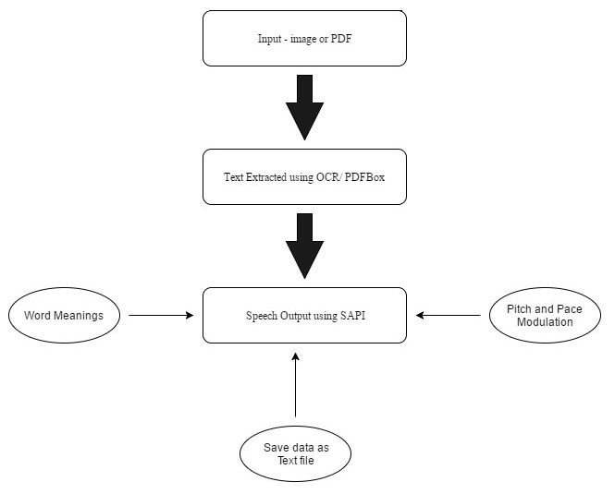
Figure 3.1 High Level Diagram of the System
The diagram shows that the system consists of two main modules which are
- Image to text conversion or text extraction from image and PDF
- Text to speech conversion
These two modules are responsible in the conversion of image to speech. The text to speech module also offers various other functionalities which are:
- Word meanings and synonyms
- Pitch and pace modulation of speech output
- Save extracted data as text file or in .txt format
Various algorithms help to do so. These are further explained in the detailed study of the system later.
3.5 Detailed Diagram
The two modules mentioned above are considered separately and their detailed diagrams are discussed below.
3.5.1 Image/PDF to Text Conversion
The diagram shows the various functionalities of this module. The various components are also discussed.
Figure 3.2 Detailed Diagram of Image/PDF to Text Conversion
On starting the application the users are presented with three options namely
- Capture an image
- Upload an image
- Upload a PDF file
The extraction of text from the different inputs is different. As shown in the diagram, extraction of text from a captured image requires natural image processing. It begins by locating the areas of the image containing text. MSER and Stroke-Width algorithms are used to do this as well as locate characters. Next Optical Character Recognition (OCR) is performed to merge the recognized characters into words and sentences. Lastly a text file is created holding the extracted text. This process is illustrated by the following diagram:
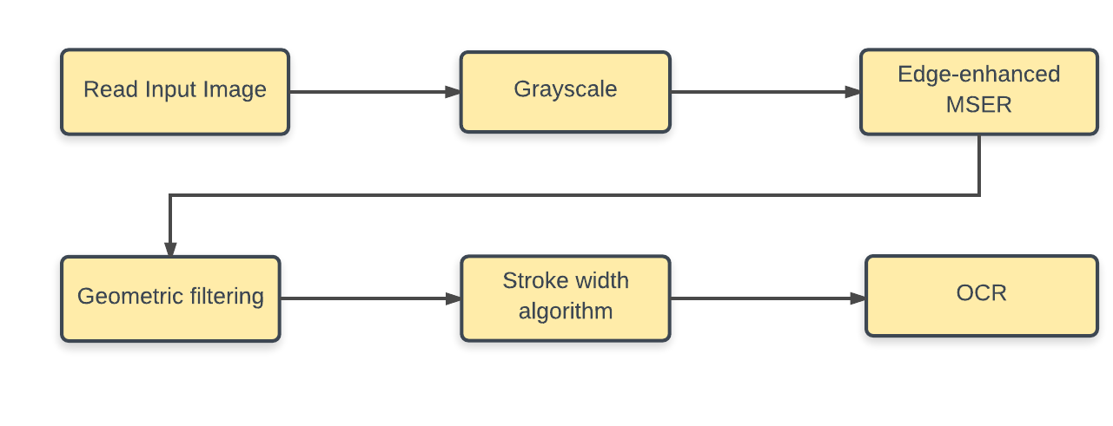
Figure 3.3 Natural Image Processing for Captured Image
Extraction of text from an uploaded image is easier. It is assumed that uploaded image is one which contains only text. Other noise has been cropped before uploading the image. The image is first copied to the working directory. OCR is performed over this image. Text extracted is then written in a file in the working directory for further processing.
Extraction of text from PDF is the easiest. It is done using a JAR file called PDFBox which is available online. This is downloaded and added to working directory. It has to noted that end users may not bother about installing or even downloading the jar. It has been incorporated in the back end code of the system. Using this, the text from the PDF is copied into a text file in the working directory for further processing.
It has to be kept in mind that algorithms to process natural image should be such that the quality of image does not hinder the accuracy with which the text is extracted. This can highly undermine the functional requirements stated before. The OCR should work sufficiently accurately for images in which text orientations are not necessarily straight and resolution is low.
Text may be present in any font style and size in image or in PDF. The algorithms should be successful in recognizing text present in any style and size. However, when it is converted in text format these details are lost as the algorithms are equipped only to copy the text and not their font size and font style. An example of this is shown later.
None of the processes mentioned above should use API. All the processes should work independently and without requiring internet. This is done to implement the functional requirement mentioned above.
The entire process of image/PDF conversion to text may take variable time. This process requires most of the code execution and is deemed to take most amount of processing time. However, the average time taken by the process has to be minimized to be close to negligible. This is because if this process has high latency, the consequent processes depending on it will be delayed exhibiting overall latency. This will reduce the efficiency of the application.

3.5.2 Text to Speech Conversion
Text which may be extracted from any kind of input is stored as a text file in the working directory. Microsoft provides a Speech API which is used to provide various voices and algorithm is written to convert this text into speech.
Figure 3.4 Text to Speech Conversion Flowchart
First image is captured or PDF is uploaded, as the case maybe. Using the previous module text is extracted from the input and converted to text format. Then text analysis is done to separate into sentences. These sentences are to be displayed in proper order alongside the speech output. Text is split into sentences whenever a full stop (‘.’) or a question mark (‘?’) or an exclamation mark (‘!’) is encountered.
The next step is verifying if Windows 32 SAPI is available in the system or not. It provides various voices like Windows Sam, Windows Mike, Windows Hazel, etc. It is useful in providing various pitches of voices to the application. If it is available, the voice objects are extracted and enumerated in GUI to be selected by users. Else only the default voices are enumerated.
This module also gives other functionalities to users. It allows users to set the pace and timing of speech. By default it is set to the slowest pace which is -10. Speed 0 is normal rate of speech. Fastest pace of speech provided is 10. Users are allowed to change the pace whenever requires.
The next facility is to interrupt the output. Users may pause or play as required. The recitation continues from the point the reading was paused. There is an option to stop the recitation altogether. This can also be availed to at any point of time during the recitation. If now the play button is pressed, it continues recitation from the beginning.
The most useful functionality provided here is the availability of word meanings. It can only be used once the recitation is on hold via pause or stop. One may search for any word whether it is in the text or not. All nearest synonyms are printed on the screen once the search button is clicked. Microsoft Word is used to find the meanings so as to avoid using the internet. This widens the scope of use of the application.
Lastly, an option to save the text in .txt format is provided. Users may not want to listen to the recitation, just save the extracted text in .txt format. This can be done by clicking the save as button. It allows users to save the extracted text in a file anywhere on the system for further processing or later use.

CHAPTER 4
IMPLEMENTATION

4.1 Programming Tool
There are a vast number of tried-and-tested programming languages to choose from, each with its own benefits and drawbacks. At the same time, a host of new programming languages continue to appear.
Matlab as programming tool: Among all Matlab is one of the most popular and efficient languages and continues to be one of the most popular programming languages in the world of image processing
We can list some but not all pros of Matlab as:
- Huge database of built-in algorithms for image processing and computer vision applications
- MATLAB allows you to test algorithms immediately without recompilation. One can type in at the command line or might as well execute a section in the editor and can immediately see the results, which in turn facilitates algorithm development.
- The MATLAB environment, allows you to work interactively with the data, it also helps you to keep track of the files and variables, and simplifies common programming and debugging tasks
- The ability to read in a wide variety of both common and domain-specific image formats.
- The ability to call external libraries, such as OpenCV
- Clearly written documentation with ample examples as well as online resources.
- The ability to process both still images and videos.
- The ability to auto generate C code, using Matlab Coder, for a large subset of image processing and mathematical functions, which you could then use in other environments, such as embedded systems
- Updates with new algorithms, features, and performance enhancements are regular.
- If already accustomed with Matlab for other purposes such as simulation, data analysis it is easy to learn it for image processing.

4.2 Code Conventions
Matlab Conventions were followed throughout our application. Among all few are listed as below:

- Write variable names in mixed case starting with lower case.
- Variables with a large scope should have meaningful names.
- Variables with a small scope are allowed to have short names
- Use the prefix n for variables representing the number of objects.
- Use the suffix No or Numor the prefix i in a variable name representing a single entity number.
- Avoid negated Boolean variable names.
- Acronyms, even if normally uppercase, should be written in mixed or lower case.
- Constants that are output by a function with the same name should have names that are all lowercase or mixed case.
- Avoid using a keyword or special value name for a variable name.
- Avoid Variable Names That Shadow Functions.
- Constant names with local scope (within an m-file) should be all uppercase using underscore to separate words.
- Consider a unit suffix for dimensioned variables and constants.
- Consider documenting important variables in comments near the start of the file.

4.3 MSER Regions
MSER is a method for blob detection in the images. This technique was first proposed by Matas et al. to find any similarities between the image elements from two images having different viewpoints. This method of extracting a comprehensive number of corresponding image elements contributes to the broad-baseline matching, and it has led to improved matching and recognition algorithms. MSER depends on the threshold of the image, if we feed them with some threshold value the pixels below that threshold value are ‘white’ and all those above or equal are black
The MSER feature detector works well for finding text regions because of the consistent colour and high contrast of text leads to stable intensity profiles. MSER can be implemented as follows:
- The first step is to sweep threshold of intensity from black to white performing a simple luminance threshold of the image.
- Once that is done extraction of the connected components or the Extremal Regions is performed.
- After that a threshold is found when an extremal region is maximally stable.
- Finally the regions descriptors as features of MSER are obtained.

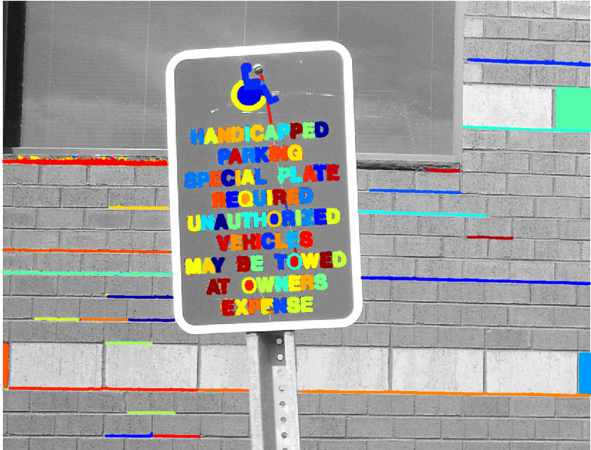
Figure 4.1 MSER Regions
As it can be observed in the above image, there are many non-text regions detected alongside the text. Although the MSER algorithm detects most of the text, it also detects several other stable regions in the image that are not text. For removing non-text region a rule based approach can be used.

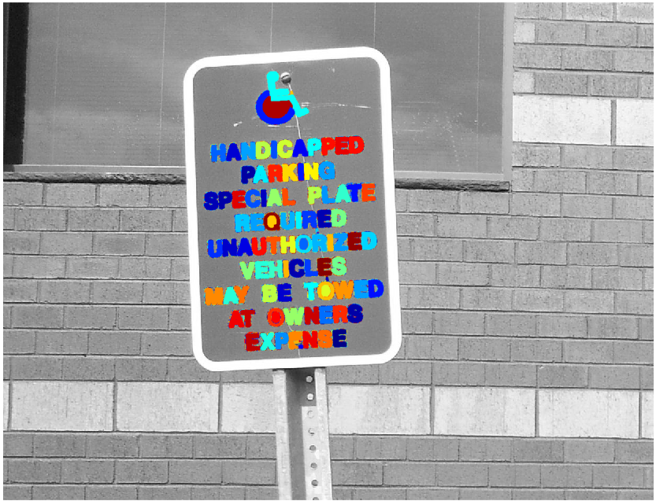
Figure 4.2 After Removing Non-Text Regions

Advantages of MSER
Since the regions are defined exclusively by the intensity function for the region as well as the outer border, this leads to the key characteristics of the regions which in turn make them important. Over a large range of thresholds, the local binarisation is stable in certain regions, and have the properties listed below.
- Invariance to affine transformation of image intensities.
- Covariance to adjacency preserving transformation T: D --> D on the image domain
- Only regions where support is closely similar over a range of thresholds is selected.
- Without any smoothening being done in multi-scale detection, both fine and large structure is detected.
- The set of all Extremal regions can be enumerated in worst-case O(n) , where n is the number of pixels in the image.

The MSER algorithm has been used in text detection by combining MSER with Canny edges. Canny edges are there to minimize the weakness of MSER to blur. MSER is first applied to the image which then determines the character regions
By replacing threshold of the intensity function MSER algorithm has been adapted to colour images. Colour object can also be tracked using the MSER algorithm, by performing MSER detection on the Mahalanobis distance to a colour distribution. Moreover, the blurriness and the scale can be modified by detecting MSERs in multiple resolutions.

4.4 Stroke Width Algorithm
The detection of text from a natural image is a complicated task . The performance of optical character recognition (OCR) algorithms can be highly increased by identifying the regions containing text in the image. Text detection in natural scenes is a challenging scenario, and there are numerous approaches for solving this problem. However, most text detection schemes restrict the user to specific languages, scale and direction of the text.
The stroke Width algorithm is a local image operator which computes per pixel width of the most likely stroke containing the pixel. The algorithm receives an RGB image and returns an image of the same size, where the regions of suspected text are marked. It comprises of three main steps: The first step is the stroke width transform, then the letter candidates are grouped based on their stroke width, and finally, grouping of letter candidates into regions of text.

The Stroke Width Transform
A stroke in the image is a continuous band of a nearly constant width. The Stroke Width Transform (SWT) is an operator which determines the width of the most likely stroke containing the pixel for each and every pixel. The output produces by the SWT is an image of the same size as of the input image where each element contains the width of the stroke associated with that pixel.

Searching letter candidates
We have now obtained a map of the most likely stroke-widths for each pixel in the original image. The next step is to group all these pixels into letter candidate. Grouping can be done by selecting two neighbouring having similar stroke width , and then applying several rules to distinguish the letter candidates. For this reason we have modified the classical Connected Component algorithm by altering the association rule from a binary mask to a predicate which compares the SWT values of the pixels.

Grouping letters into lines of text
To increase the efficiency and reliability we strive forward to group the letters. Since single letters are not expected to appear in images, closely positioned letter candidates are gathered together into regions of text.
The overall process of the Stroke Width Algorithm is shown below

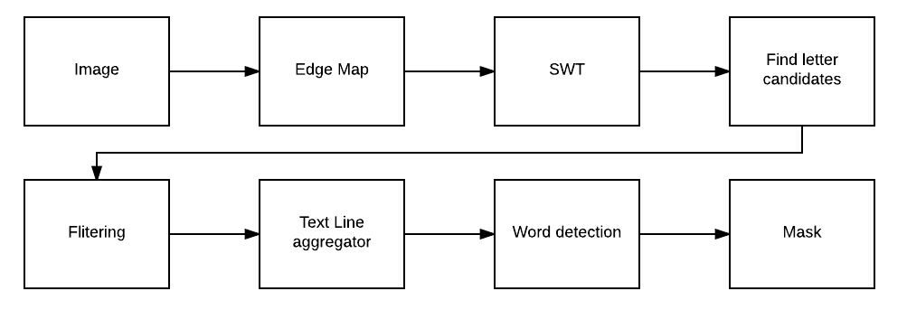
Figure 4.3 Flowchart of the algorithm

In the figure shown below, the stroke width image has a little variation over majority of the region. This shows that the region is more likely to be a text region because the lines and curves that make up the region all have similar widths, which is a common characteristic of human readable text.

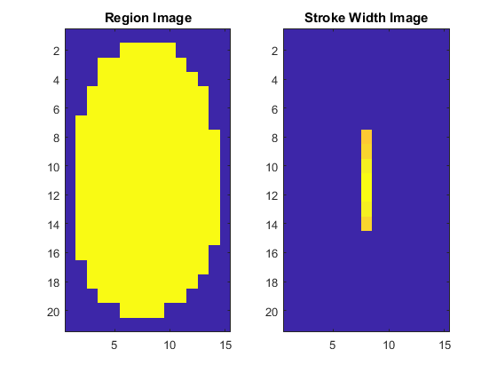
Figure 4.4 Variation of Image

The variation over the entire region must be quantified into a single metric to properly use stroke width variation to remove non-text regions using a threshold value
Then, a threshold can be applied to remove the non-text regions. This threshold value may require tuning for images with different font styles.

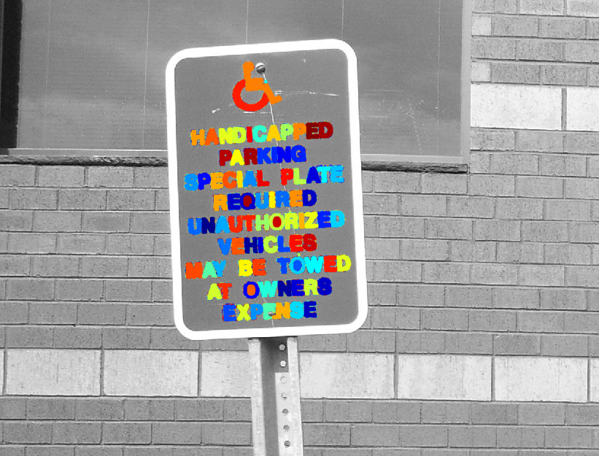
Figure 4.5 After removing non- text region based on Stroke Width Algorithm

The figure shown above depicts the image after removing all the non-text regions using the Stroke width algorithm.

4.5 Optical Character Recognition
Optical Character Recognition is the process of converting the text, present in digital image, into editable text. It enables a machine to identify the characters through optical mechanisms. The output of the OCR should ideally be same as input in formatting. The process involves pre-processing of the image file and then acquiring of important information about the written text.

Design of OCR
The design of OCR systems involves various approaches as mentioned below:

Matrix Matching: Matrix matching each character is converted into a pattern inside a matrix, and then the pattern is compared with an index of already known characters. Its recognition is the most accurate on monotype and uniform single column pages.

Fuzzy Logic: Fuzzy logic is a multi-valued logic which allows intermediate values to be defined in between conventional evaluations like black/white, yes/no, true/false etc. In cases where no direct answers are available and uncertainty is involved fuzzy logic is used extensively.

Feature Extraction: The key features, like height, width, density, loops, lines, stems and other character traits are analysed for defining each and every character.Feature extraction is an ideal approach for OCR of high quality images, news articles, journals.

Structural Analysis: Structural Analysis selects characters by inspecting their sub features like structure of the image, sub-vertical and horizontal histograms. It also provides great character repair for low quality text and newsprints.

Neural Networks: This strategy simulates the way the human neural system functions. It takes the pixels in each image and tallies them to a known index of character pixel patterns. Its ability to identify the characters through abstraction is great for damaged text and faxed documents. Neural networks are suited for specific types of problems, such as finding trends in graphical patterns or processing stock market data.

Structure of OCR
The OCR structure consists of various stages which are depicted below.

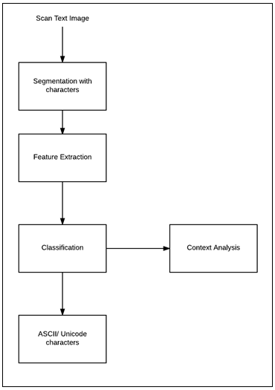
Figure 4.6 Stages in OCR Design

4.6 Code Snippet

%% Step 1: Detect Candidate Text Regions Using MSER
colorImage = imread(‘testframe.jpg');
I = rgb2gray(colorImage);

% Detect MSER regions.
[mserRegions, mserConnComp] = detectMSERFeatures(I, ...
'RegionAreaRange',[200 8000],'ThresholdDelta',4);

%% Step 2: Remove Non-Text Regions Based On Basic Geometric Properties
% Use regionprops to measure MSER properties
mserStats = regionprops(mserConnComp, 'BoundingBox', 'Eccentricity', ...
'Solidity', 'Extent', 'Euler', 'Image');

% Compute the aspect ratio using bounding box data.
bbox = vertcat(mserStats.BoundingBox);
w = bbox(:,3);
h = bbox(:,4);
aspectRatio = w./h;

% Threshold the data to determine which regions to remove. These thresholds
% may need to be tuned for other images.
filterIdx = aspectRatio' > 3;
filterIdx = filterIdx | [mserStats.Eccentricity] > .995 ;
filterIdx = filterIdx | [mserStats.Solidity] < .3;
filterIdx = filterIdx | [mserStats.Extent] < 0.2 | [mserStats.Extent] > 0.9;
filterIdx = filterIdx | [mserStats.EulerNumber] < -4;

% Remove regions
mserStats(filterIdx) = [];
mserRegions(filterIdx) = [];

%% Step 3: Remove Non-Text Regions Based On Stroke Width Variation
% during the stroke width computation.
regionImage = mserStats(6).Image;
regionImage = padarray(regionImage, [1 1]);

% Compute the stroke width image.
distanceImage = bwdist(~regionImage);
skeletonImage = bwmorph(regionImage, 'thin', inf);

strokeWidthImage = distanceImage;
strokeWidthImage(~skeletonImage) = 0;
% Compute the stroke width variation metric
strokeWidthValues = distanceImage(skeletonImage);
strokeWidthMetric = std(strokeWidthValues)/mean(strokeWidthValues);

% Threshold the stroke width variation metric
strokeWidthThreshold = 0.4;
strokeWidthFilterIdx = strokeWidthMetric>strokeWidthThreshold;

for j = 1:numel(mserStats)

regionImage = mserStats(j).Image;
regionImage = padarray(regionImage, [1 1], 0);

distanceImage = bwdist(~regionImage);
skeletonImage = bwmorph(regionImage, 'thin', inf);

strokeWidthValues = distanceImage(skeletonImage);

strokeWidthMetric = std(strokeWidthValues)/mean(strokeWidthValues);

strokeWidthFilterIdx(j) = strokeWidthMetric>strokeWidthThreshold;

end

% Remove regions based on the stroke width variation
mserRegions(strokeWidthFilterIdx) = [];
mserStats(strokeWidthFilterIdx) = [];

%% Step 4: Merge Text Regions For Final Detection Result
% Get bounding boxes for all the regions
bboxes = vertcat(mserStats.BoundingBox);

% Convert from the [x y width height] bounding box format to the [xminymin
% xmaxymax] format for convenience.
xmin = bboxes(:,1);
ymin = bboxes(:,2);
xmax = xmin + bboxes(:,3) - 1;
ymax = ymin + bboxes(:,4) - 1;

% Expand the bounding boxes by a small amount.
expansionAmount = 0.02;
xmin = (1-expansionAmount) * xmin;
ymin = (1-expansionAmount) * ymin;
xmax = (1+expansionAmount) * xmax;
ymax = (1+expansionAmount) * ymax;

% Clip the bounding boxes to be within the image bounds
xmin = max(xmin, 1);
ymin = max(ymin, 1);
xmax = min(xmax, size(I,2));
ymax = min(ymax, size(I,1));

% Show the expanded bounding boxes
expandedBBoxes = [xminymin xmax-xmin+1 ymax-ymin+1];
IExpandedBBoxes = insertShape(colorImage,'Rectangle',expandedBBoxes,'LineWidth',3);

% Compute the overlap ratio
overlapRatio = bboxOverlapRatio(expandedBBoxes, expandedBBoxes);

% Set the overlap ratio between a bounding box and itself to zero to
% simplify the graph representation.
n = size(overlapRatio,1);
overlapRatio(1:n+1:n^2) = 0;

% Create the graph
g = graph(overlapRatio);

% Find the connected text regions within the graph
componentIndices = conncomp(g);

% Merge the boxes based on the minimum and maximum dimensions.
xmin = accumarray(componentIndices', xmin, [], @min);
ymin = accumarray(componentIndices', ymin, [], @min);
xmax = accumarray(componentIndices', xmax, [], @max);
ymax = accumarray(componentIndices', ymax, [], @max);

% Compose the merged bounding boxes using the [x y width height] format.
textBBoxes = [xminymin xmax-xmin+1 ymax-ymin+1];

% Remove bounding boxes that only contain one text region
numRegionsInGroup = histcounts(componentIndices);
textBBoxes(numRegionsInGroup == 1, :) = [];

%% Step 5: Recognize Detected Text Using OCR
ocrtxt = ocr(I, textBBoxes);
recognizedText = [ocrtxt.Text];
if(~isempty(recognizedText))
fid = fopen(‘Text.txt','wt');
fprintf(fid, recognizedText);
fclose(fid);
end
Chapter 5
TESTING AND RESULTS
Using the techniques described above the system is tested. Testing is required to provide information about the quality of the system developed. It verifies if the system is fit for use. Testing is done at various levels. These are described below.
5.1 Unit Tests
Unit testing is the testing of functionality of a specific section of code, usually at the function level or at class level in case of an object-oriented environment. Unit testing alone cannot verify the functionality of a part of software. Instead it is used to ensure that the building blocks of the software work efficiently independent from each other.
The following table shows a list of unit tests, the expected result of application’s behaviour when subjected to these tests and observed results.
Test Case | Description | Expected Result | Result
1 | Capture Image from Webcam | - Start Camera  - Capture and save image  - Move to next window | PASS
2 | Upload an Image from PC | - Browse to select file of specified format only  - Move to next window | PASS
3 | Upload a PDF file from PC | - Browse to select file  - Move to next window | PASS
4 | Recite text extracted from image or PDF file | - Recite text sentence wise when Play button clicked  - Pause the recitation when Pause button clicked  - Stop recitation when Stop button clicked  - Option to search word meaning when recitation paused or stopped  - Change voice of recitation  - Change speed or speech  - Save Text file containing extracted text in location specified | PASS
Test Case | Description | Expected Result | Result
5 | Capture Blur or Low Resolution Image from Camera | - Start Camera  - Capture Blur Image  - Click Next  - Error: “Text cannot be extract, please retry” | PASS
6 | Give Incorrect Path to Upload Image | - Enter a path to image that does not exist  - Click next  - Error: “Image does not exist, please retry” | PASS
7 | Give Incorrect Path to Upload PDF File | - Enter a path to PDF that does not exist  - Click next  - Error: “File does not exist, please retry” | PASS
8 | Search for a non-existent word meaning | - Pause/Stop recitation  - Search for a word that does not exist  - Error: “Incorrect spelling, please recheck” | PASS
Table 5.1 Unit Test Cases and Results
These tests not only check the working of favourable cases but also unfavourable cases. The components are fed with erroneous inputs and their behaviour is checked. Components should handle these cases by displaying appropriate message to the users and direct them to further actions. It is seen that the system passes such tests. Hence the non-functional requirement – reliability is taken care of.

5.2 Integration Tests
Integration testing is one that seeks to verify the interfaces between components against a software design. Integration testing works to expose defects in the interfaces and interaction between integrated modules. First components are tested for individual working. If these components pass the unit tests, they are integrated progressively into larger groups of tested software components corresponding to elements of the architectural design and tested until the software works as a system.
The following table shows a list of integration tests, the expected result of application’s behaviour when subjected to these tests and observed results.
Test Case | Description | Expected Result | Result
1 | Start application, Capture Image from Webcam, Recite Text | - Start application – Splash Screen  - Select Take Picture option  - Start Camera  - Capture Image  - Move to Final Window  - Display text sentence wise and recite the same  - Provide options of Pause/Play, Stop, Save Text File, Search Word Meanings, Change Speech Voice and Speed | PASS
2 | Start application, Upload Image from PC, Recite Text | - Start application – Splash Screen  - Select Upload Picture option  - Start File Selector to Browse and select image of specified format only  - Move to Final Window  - Display text sentence wise and recite the same  - Provide options of Pause/Play, Stop, Save Text File, Search Word Meanings, Change Speech Voice and Speed | PASS
Test Case | Description | Expected Result | Result
3 | Start application, Upload PDF File from PC, Recite Text | - Start application – Splash Screen  - Select Upload PDF File option  - Start File Selector to Browse and select PDF file from PC  - Move to Final Window  - Display text sentence wise and recite the same  - Provide options of Pause/Play, Stop, Save Text File, Search Word Meanings, Change Speech Voice and Speed | PASS
Table 5.2 Integration Test Cases and Results
System testing is useful to test the complete integrated system to verify that the system meets its functional requirements. These integration tests act as system tests. This is because the system consists of two components. Hence when we test the integration of these two components the system tests are covered. The end to end functioning of the components is tested through integration tests itself.

5.3 Results
As described above the application consists of two phases namely image to text conversion and text to speech conversion. Input is an image or PDF. Intermediate stage consists of a text file. Finally the output is in form of speech. Supporting visuals are present in the application along with various other facilities. They are shown below.
5.3.1 Capture Natural Image
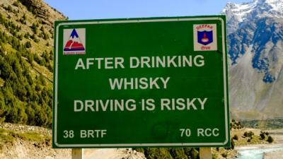
Figure 5.1 Captured Image of a Street Sign
The above figure is the input to the system. It is pre-processed and OCR is performed to extract the embedded text.
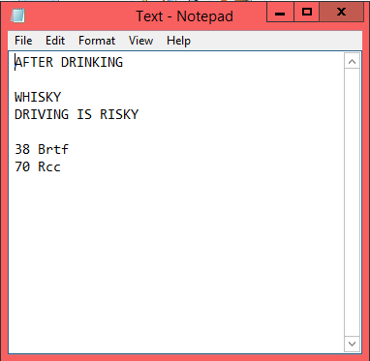
Figure 5.2 Text File Creation
The intermediate stage consists of a text file containing the extracted text as shown above.
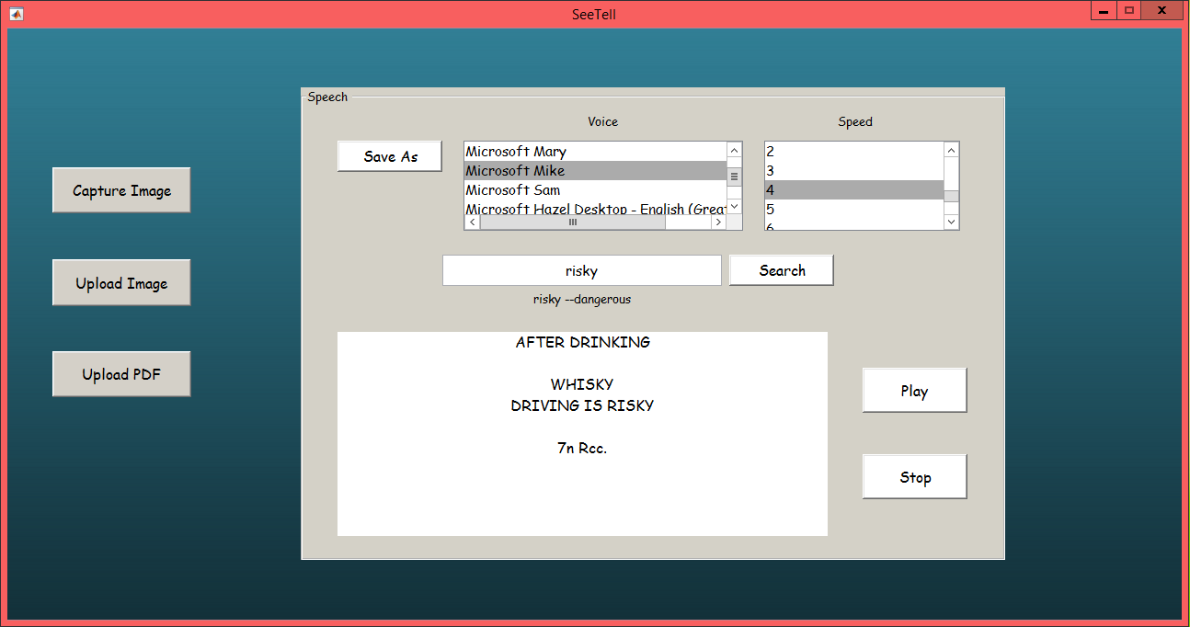
Figure 5.3 Conversion to Speech
Here we see that the intermediate text is displayed sentence wise along with the speech. The other functionalities are available. Pitch is set as Microsoft Mike and pace is set to 4. Word meaning of “risky” is searched and result is displayed alongside.
5.3.2 Upload Image
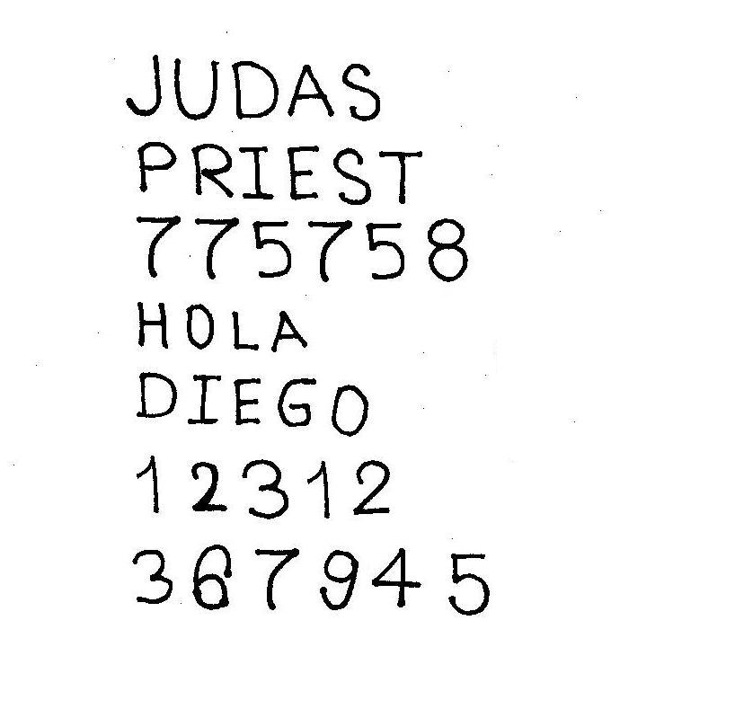
Figure 5.4 Uploaded an Image of Handwritten Text
The above figure is of a handwritten document which is input to the system. OCR is performed to extract the embedded text.
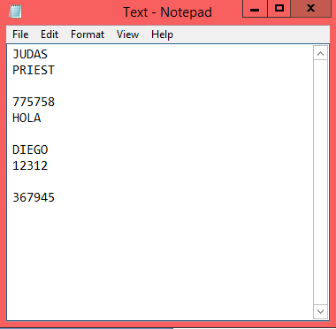
Figure 5.5 Text File Creation
The intermediate stage consists of a text file containing the extracted text as shown above.
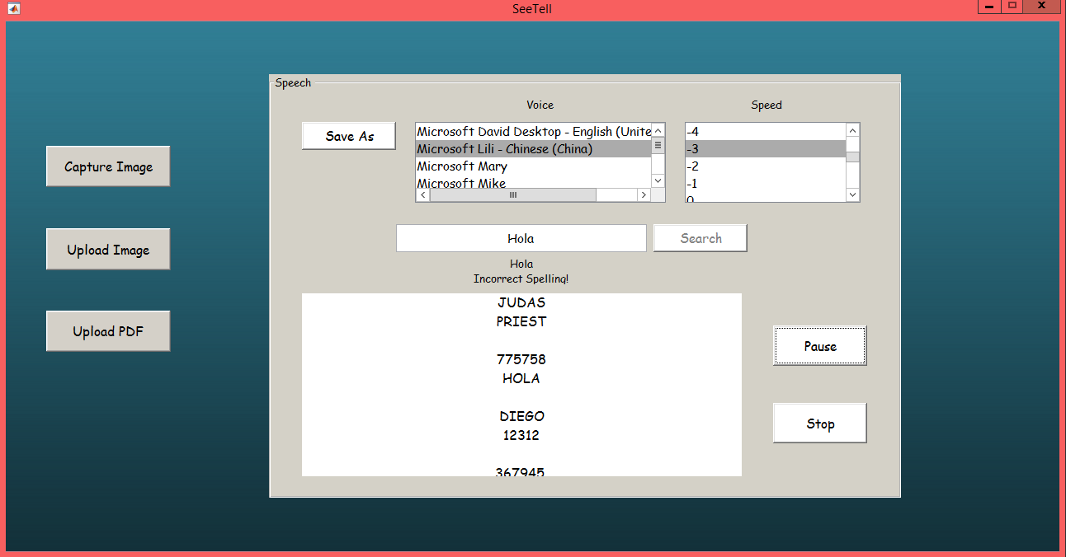
Figure 5.6 Conversion to Speech
Here we see that the intermediate text is displayed sentence wise along with the speech. The other functionalities are available. Pitch is set as Microsoft Lilli - Chinese and pace is set to -3, which is to the slower side. Word meaning of “hola” is searched and error message is displayed.

5.3.3 Upload PDF
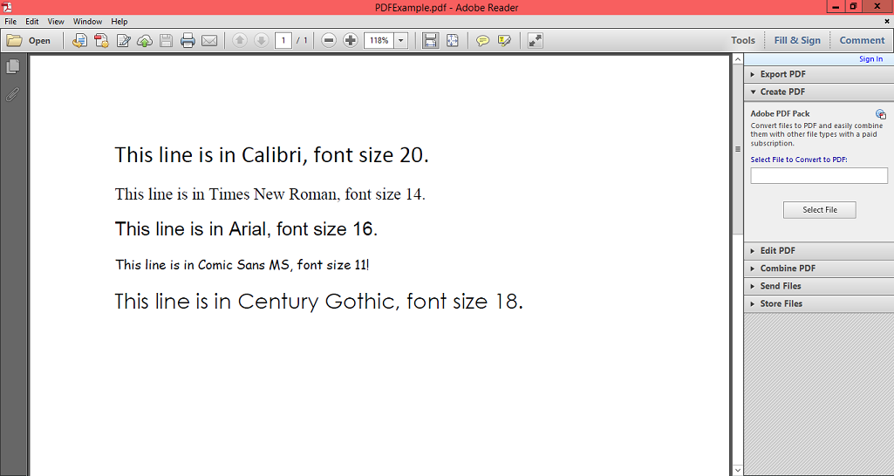
Figure 5.7 Uploaded a PDF file containing text in different fonts and font sizes
The above figure is the screenshot of a PDF file which is input to the system. It is processed and embedded text is extracted.
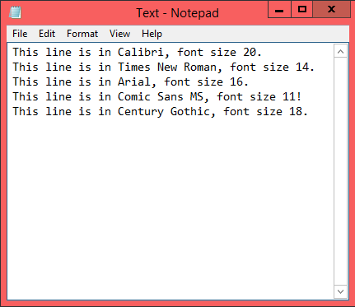
Figure 5.8 Text Extraction
The intermediate stage consists of a text file containing the extracted text as shown above. The formatting is lost but the information is accurately captured.
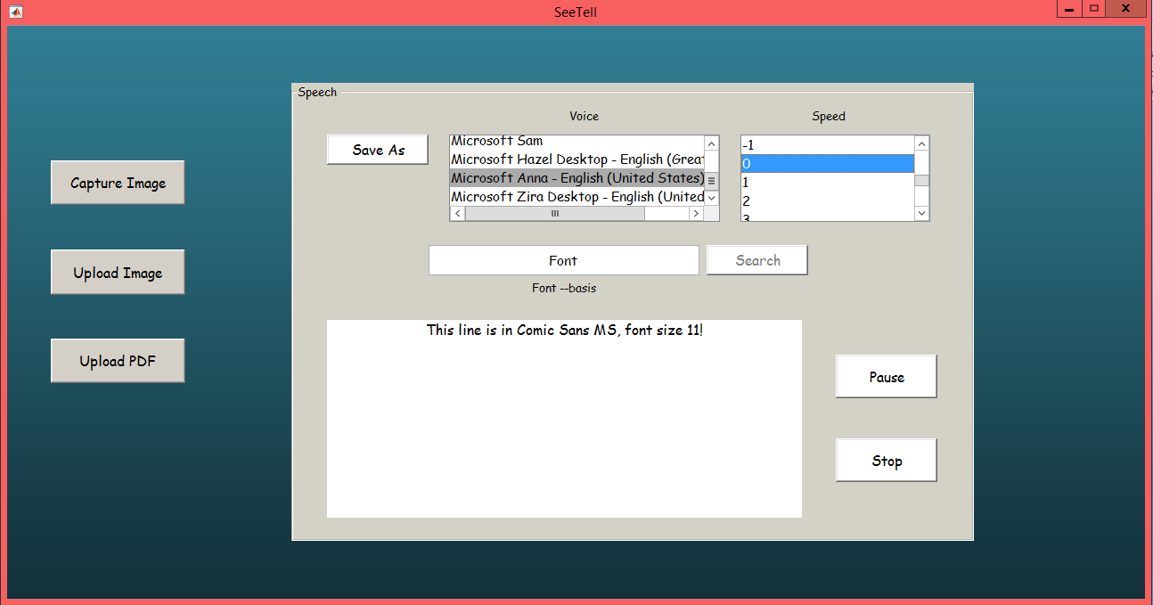
Figure 5.9 Conversion to Speech
Here we see that the intermediate text is displayed sentence wise along with the speech. The other functionalities are available. Pitch is set as Microsoft Anna – United States and pace is set to 0, which is the normal pace. Word meaning of “font” is searched and corresponding meaning is displayed.
The above show that the system accepts inputs in three ways. The corresponding outputs are also shown. It can be observed that the accuracy is maintained. The functional and non-functional requirements are implemented.

5.4 Result Analysis
We will discuss the various algorithms used in the making of SeeTell. We compare it with other existing algorithms too.

5.4.1 Accuracy of Algorithm for OCR
Commissioned by the U.S. Department of Energy (DOE), the Information Science Research Institute (ISRI) had the mission to foster the improvement of automated technologies for understanding machine printed documents, and it conducted the most authoritative of the Annual Test of OCR Accuracy from 1992 to 1996.
Recognition of Latin-script, typewritten text is still not 100% accurate even where clear imaging is available. One study based on recognition of 19th- and early 20th-century newspaper pages concluded that character-by-character OCR accuracy for commercial OCR software varied from 81% to 99%;, total accuracy can be achieved by human review or Data Dictionary Authentication. Other areas—including recognition of hand printing, cursive handwriting, and printed text in other scripts (especially those East Asian language characters which have many strokes for a single character)—are still the subject of active research. The MNIST database is commonly used for testing systems' ability to recognise handwritten digits.
Accuracy rates can be measured in several ways, and how they are measured can greatly affect the reported accuracy rate. For example, if word context (basically a lexicon of words) is not used to correct software finding non-existent words, a character error rate of 1% (99% accuracy) may result in an error rate of 5% (95% accuracy) or worse if the measurement is based on whether each whole word was recognised with no incorrect letters.

5.4.2 Short comings of OCR Systems
Existing OCR systems generally show poor performance for documents like old books: print and paper quality inferior due to aging, Copied Materials: documents like photocopies or faxed documents, where print quality is inferior to the original, Newspapers: generally printed on low quality paper etc. For such degraded documents, the system recognition accuracy comes down to 80- 90%. But if we want to use the OCR system for Banking and Corporate sector, this accuracy rate is not up-to-mark.

5.4.3 Comparison to other region detectors
In Mikolajczyk et al., six region detectors are studied (Harris-affine, Hessian-affine, MSER, edge-based regions, intensity extrema, and salient regions). A summary of MSER performance in comparison to the other five follows.
- Region density - in comparison to the others MSER offers the most variety detecting about 2600 regions for a textured blur scene and 230 for a light changed. scene, and variety is generally considered to be good. Also MSER had a repeatability of 92% for this test.
- Region size - MSER tended to detect many small regions, versus large regions which are more likely to be occluded or to not cover a planar part of the scene. Though large regions may be slightly easier to match.
- Viewpoint change - MSER outperforms the five other region detectors in both the original images and those with repeated texture motifs.
- Scale change - Following Hessian-affine detector, MSER comes in second under a scale change and in-plane rotation.
- Blur - MSER proved to be the most sensitive to this type of change in image, which is the only area that this type of detection is lacking in.
Note however that this evaluation did not make use of multi-resolution detection, which has been shown to improve repeatability under blur.
- Light change - MSER showed the highest repeatability score for this type of scene, with all the other having good robustness as well.
MSER consistently resulted in the highest score through many tests, proving it to be a reliable region detector.

5.4.4 Extensions and Adaptations
- The MSER algorithm has been adapted to colour images, by replacing thresholding of the intensity function with agglomerative clustering, based on colour gradients.
- The MSER algorithm can be used to detect regions based on colour as opposed to intensity. This is done by Chavez by creating an intensity function for red, green, and blue in the HSV colour space. The MSER algorithm is then run five times; over the three colour pseudo-intensities and then over the grey scale intensities using the standard MSER+ and MSER- functions.
- The MSER algorithm can be used to track colour objects, by performing MSER detection on the Mahalanobis distance to a colour distribution.
- By detecting MSERs in multiple resolutions, robustness to blur, and scale change can be improved
5.4.5 Relevance of the Application
Our application uses methods and functions requiring minimal time. The output of these algorithms help to caters to various domains of users. It is used to accomplish the following:
- Visually impaired individuals can read newspapers, article and other books that are not published in Braille.
- Blind people who cannot read in Braille can still avail to books articles etc with minimal assistance.
- Children can learn the language in a more interesting manner.
- People of all ages who are new to the language can understand basic signs, banners etc. that they encounter in their everyday life.
- With the availability of synonyms and word meanings in the application itself users do not have to bother to search anything in numerous places.
- It is convenient and easy to use so that the ones who do not have much knowledge about the workings of a computer could still make use of this application
- Expensive hardware component, support software, updated Operating System version or even internet connection is not required. A webcam, to capture image, is an optional requirement.
- The provision to change voice and speed of speech enables different domains of users to customize the speech output as suitable. This freedom can help them grasp the recitation comfortably.
- Handwritten documents can also be uploaded and converted to speech, provided the handwriting is clear. This widens the scope of usability of the application.
- This can help users multitask as they can do mundane chores whist their computer recites material aloud for them.

It can be thus observed that this application serves the society in variety of ways.

5.5 Error Handling
An ideal application should be able to handle difficult situations. All error conditions should be taken care of. It should be intimidated to users clearly. Not only that, users should be guided as to what actions to take subsequently.
SeeTell strives to be as user friendly as possible. The non-functional requirement is taken care of. Various error conditions are handled. They are described below.
5.5.1 When a natural image is captured containing no text
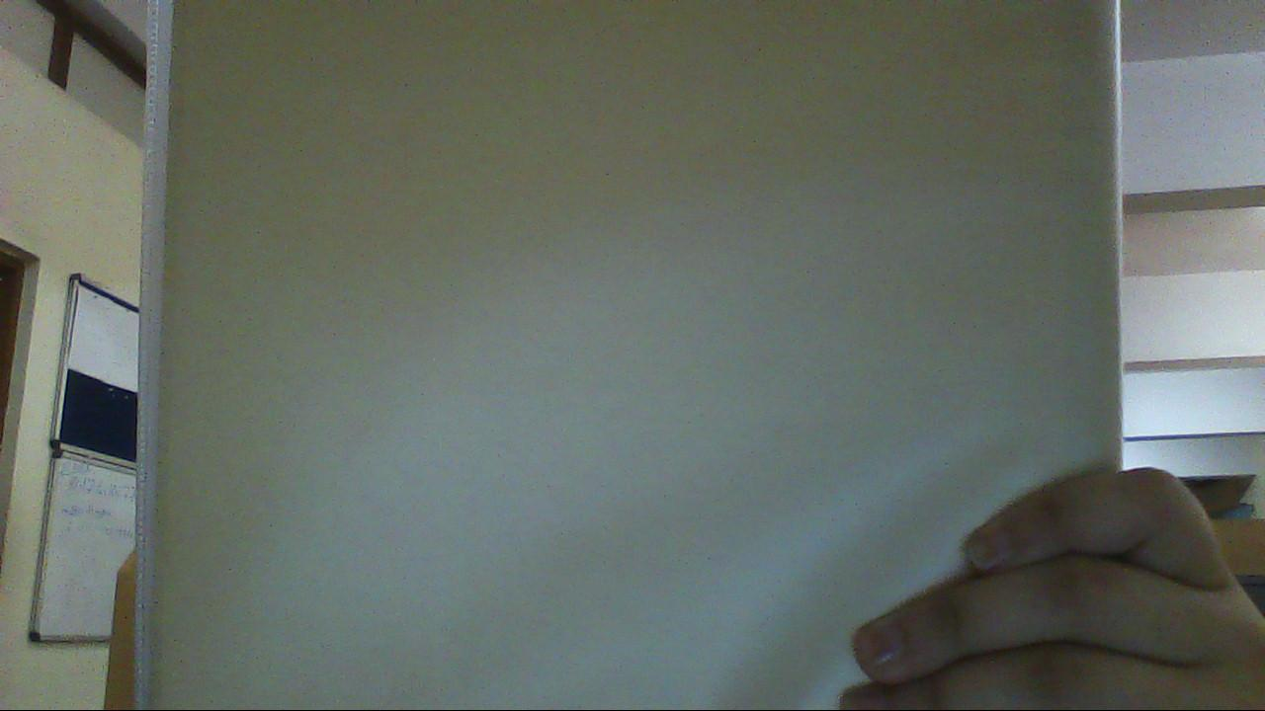
Figure 5.10 Natural image Without Text
It is expected that the application informs user about the situation. It should direct user to repeat the process of image capture.
The screen shot of SeeTell handling this error is shown below.
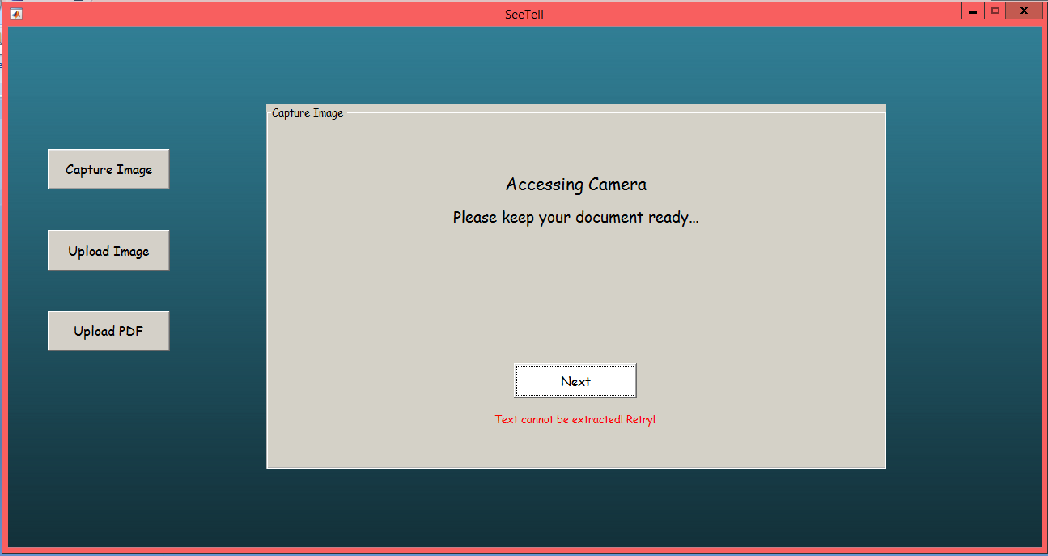
Figure 5.11 Error Handling for natural image is captured containing no text
Hence it is observed that this situation is taken care of efficiently by SeeTell.

5.5.2 When blur natural image is captured
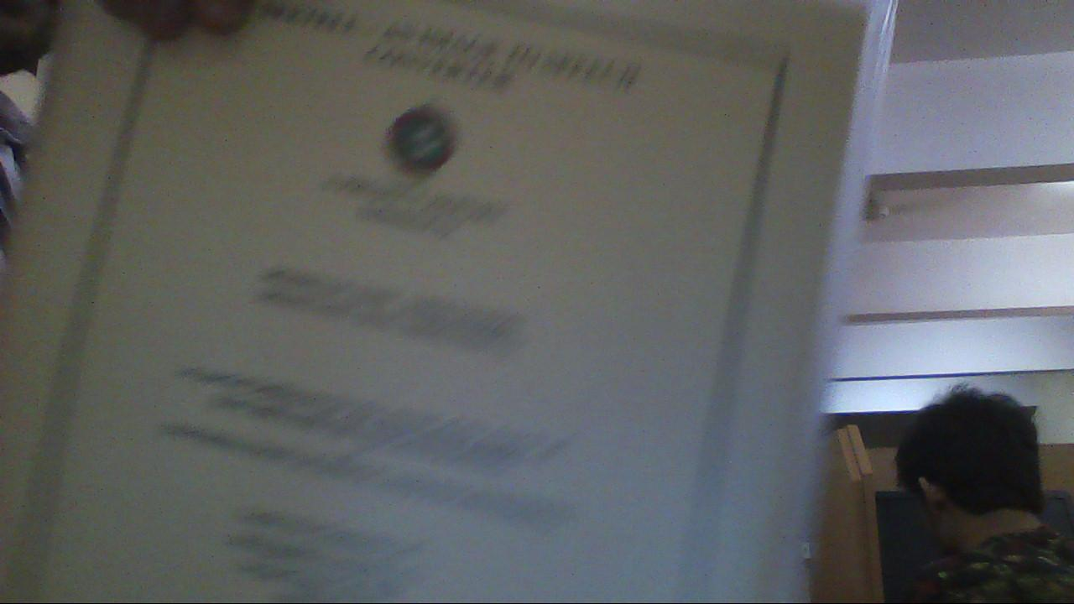
Figure 5.12 Blur natural image
It is expected that the application informs user about the situation. Such an image is not permitted since the application should not re-create faulty information about the document. It should direct user to repeat the process of image capture.
The screen shot of SeeTell handling this error is shown below.
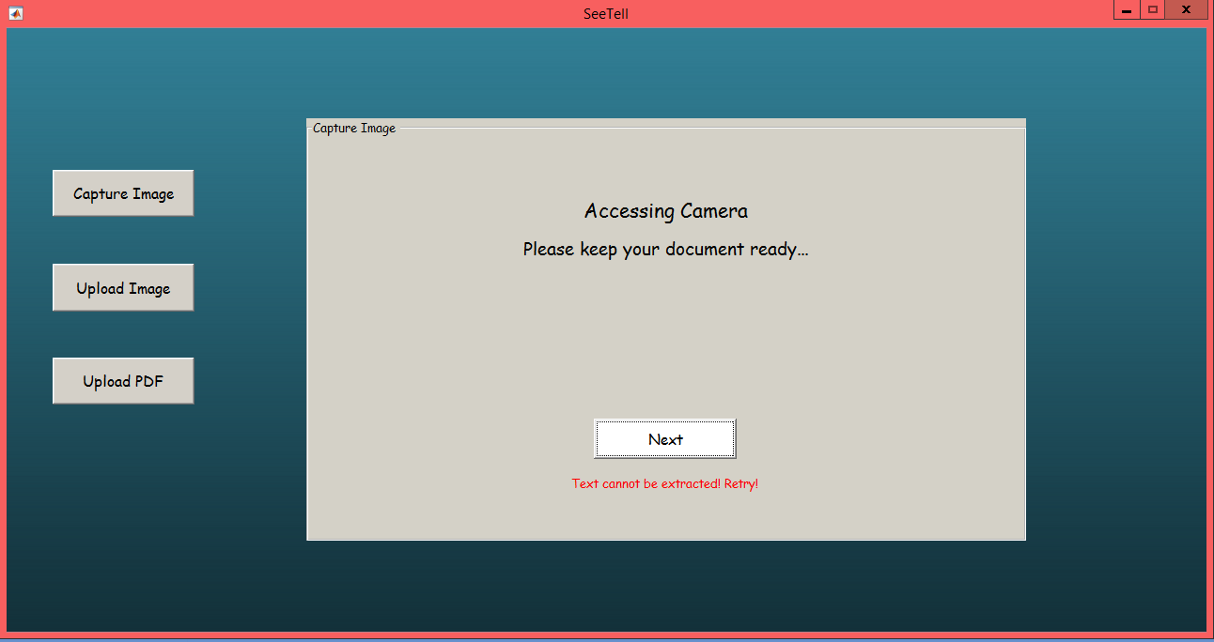
Figure 5.13 Error Handling for blur Natural image
5.5.3 When no file path is entered to “Upload Image” module
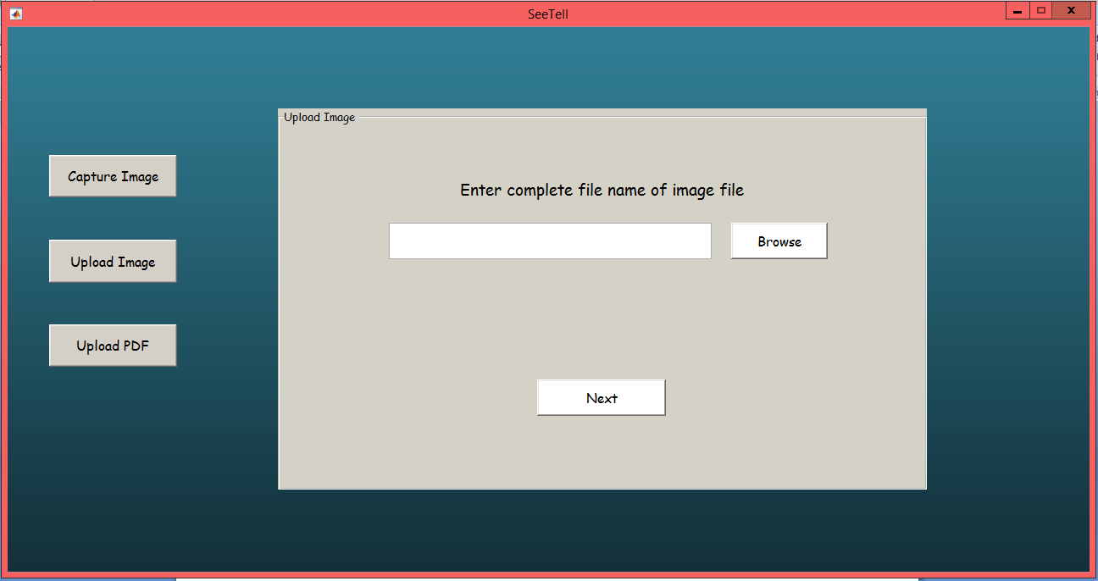
Figure 5.14 No image file path entered
In such a case the system should intimate user asking him to enter a valid path to the application. Failing to do so, user should not be allowed to proceed.
The screen shot of SeeTell handling this error is shown below.
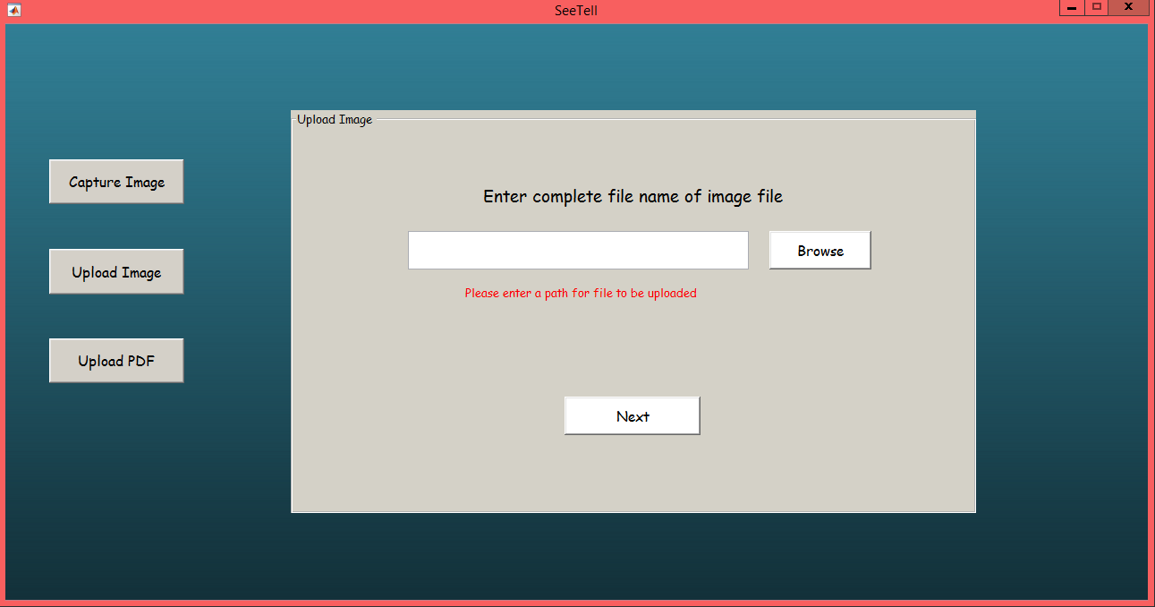
Figure 5.15 Error handling for no image file path entered
5.5.4 When incorrect file path is entered to “Upload Image” module
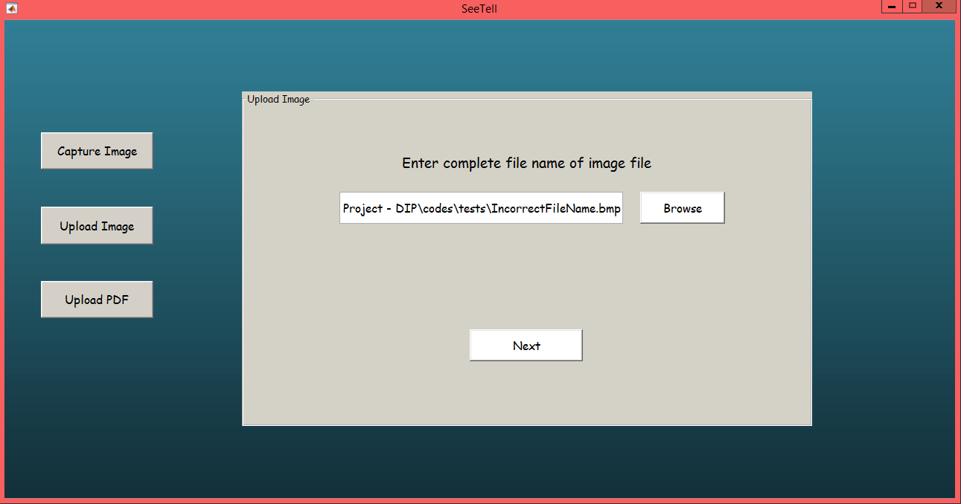
Figure 5.16 Incorrect image file path entered
User should be informed that it is necessary for him to enter a file path of existing file. He should be redirected to enter a valid path. Failing to do so, user should not be allowed to proceed.
The screen shot of SeeTell handling this error is shown below.
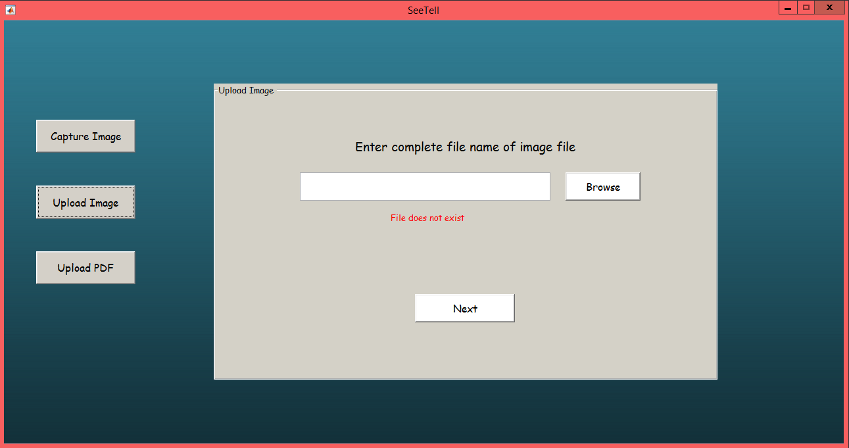
Figure 5.17 Error handling for invalid image file path entered
5.5.5 When no file path is entered to “Upload PDF module
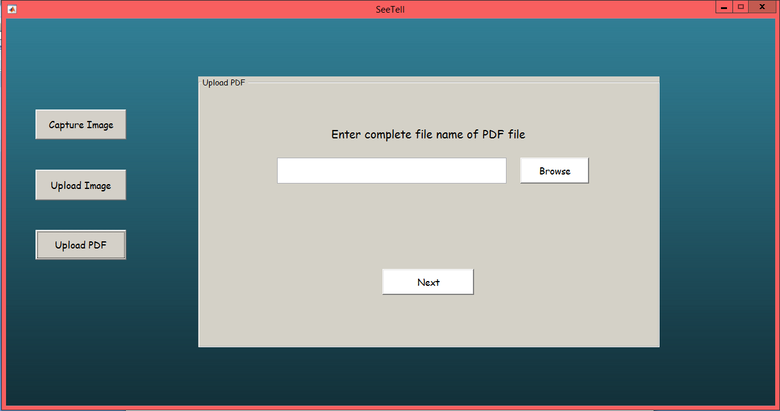
Figure 5.18 No PDF file path entered
In such a case the system should intimate user asking him to enter a valid path to the application. Failing to do so, user should not be allowed to proceed.
The screen shot of SeeTell handling this error is shown below.
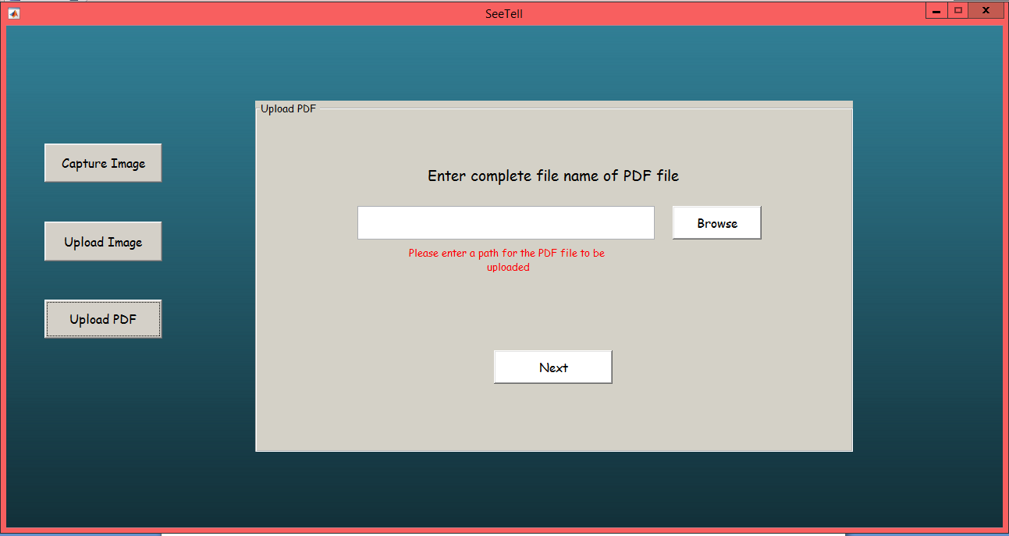
Figure 5.19 Error handling for no PDF file path entered

5.5.6 When incorrect file path is entered to “Upload PDF” module
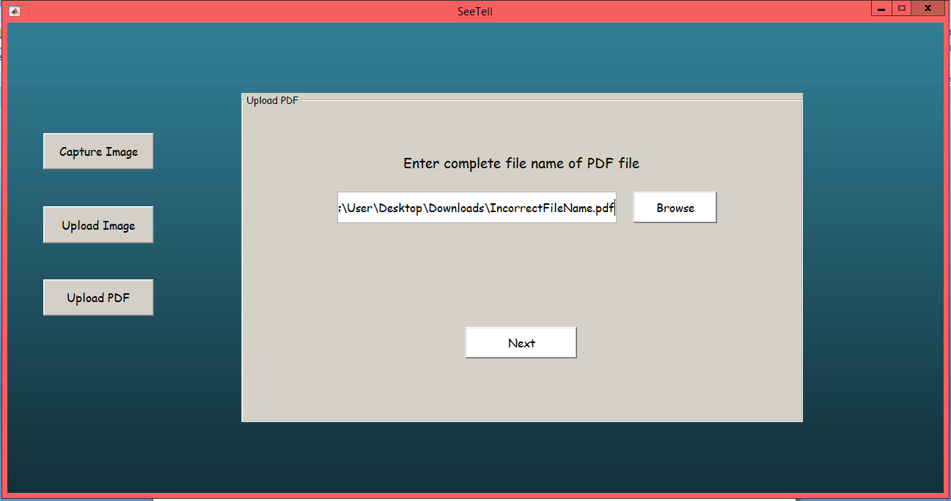
Figure 5.20 Incorrect PDF file path entered
User should be informed that it is necessary for him to enter a file path of existing file. He should be redirected to enter a valid path. Failing to do so, user should not be allowed to proceed.
The screen shot of SeeTell handling this error is shown below.
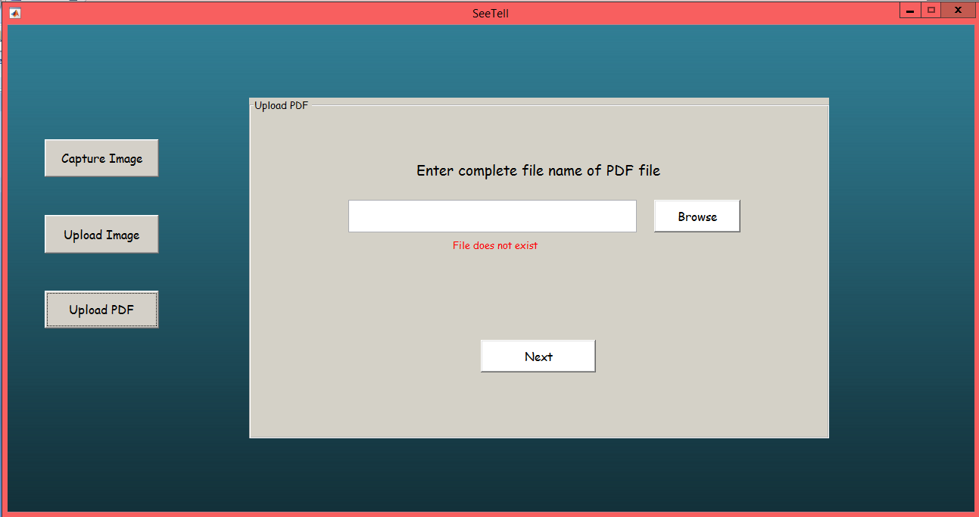
Figure 5.21 Error handling for invalid PDF file path entered

5.6 Restricting Input

All kinds of input are not accepted for image as well as PDF. Only specified formats are accepted for image inputs . Documents to be scanned should strictly be in the specified format.

5.6.1 Image formats Restriction
Formats for images which are supported are (.bmp, .gif, .png, .jpeg , .jpg)

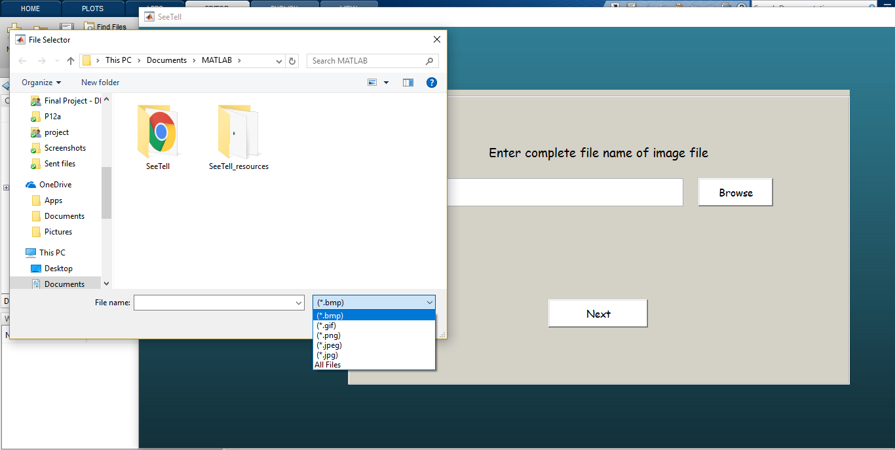
Fig 5.22 Image Input Restriction.
Users are allowed to upload image which is in specified formats. Future updates may allow users to upload images in other formats.

5.6.2 Document Format Restriction

Documents should be strictly in .pdf format.

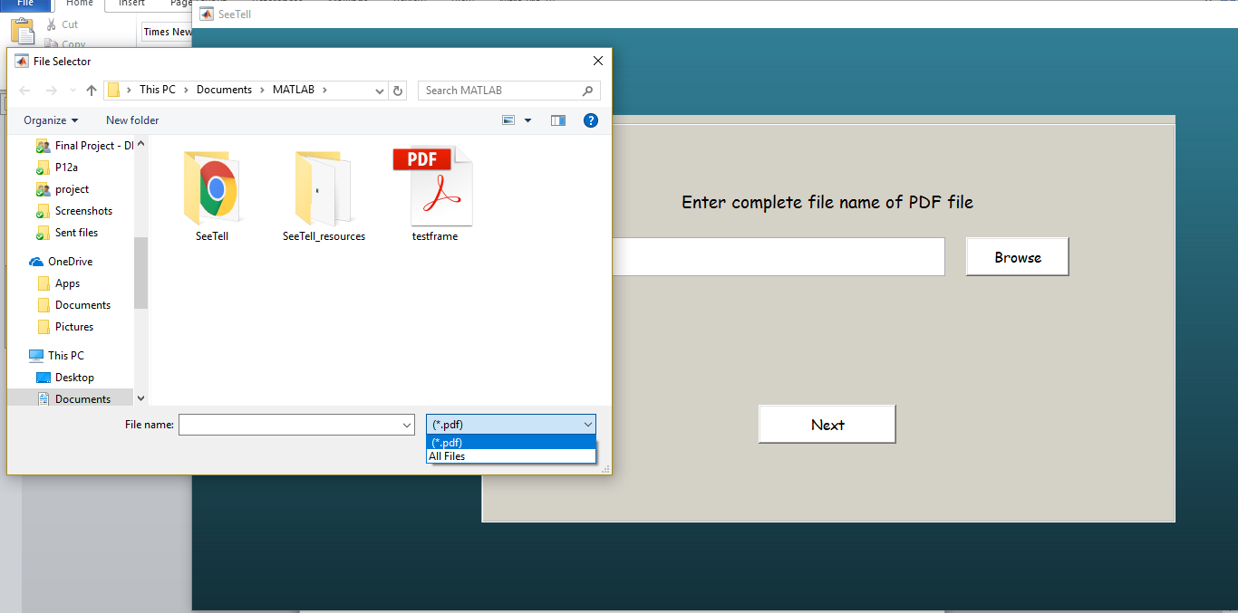
Fig 5.23 Document Input Restriction
Users are allowed to upload document which is in PDF formats. Future updates may allow users to upload documents in other formats.

CONCLUSION
Text to speech conversion is a fast growing aspect of computer technology and has become an important criterion in determining the way we interact with the system and interfaces across a variety of platforms. This project intends to propose an approach for image to speech conversion using optical character recognition and speech synthesis. The application developed is simple to use, very cost effective, portable and applicable in the real time. Using it we can read text from any natural image, any document image as well as PDF documents and also it can generate synthesized speech through a computer's speakers. The developed software has incorporated features like word meaning assistance and voice modulation along with speed control. This can enable user to multitask and save time by listening to background materials while doing some other tasks. This system can be used in parts as well. For instance, if we want just the text conversion it is also possible moreover only text to speech can also be performed separately. Expensive hardware component, support software, updated Operating System version or even internet connection is not required. A webcam, to capture image, is an optional requirement. People with visual impairments or complete blindness can use this application for reading the documents and books. People with learning disabilities can also make use of this application. It is convenient and easy to use for those who do not have much knowledge about the workings of a computer but still make use of this application The dictionary feature added intends to help understand the text With the availability of synonyms and word meanings in the application itself users do not have to bother to search anything in numerous places. Tests have been conducted to check the conversion and good results have been achieved.

FUTURE SCOPE
SeeTell has been developed keeping in mind the primary functional and non-functional requirements. It is version 1.0 of the system. There is scope to add more functionality to it. Existing functionalities can be improved too. Some of the near future developments have been listed below.
- Support for languages other than English can be added. For people in India, adding Hindi would be beneficial. Globally seeing, French can be one of the next languages to be added.
- Algorithms used to pre-process a natural image works sufficiently in this system. However, there is scope to improve it further. The same goes for OCR.
- Support for more formats of image inputs can be provided.
- Algorithms can be developed to recognize text from low resolution and blur images. This will help users to upload old historic manuscripts and scrolls which have been damaged and extract text from it.
- Detailed word meanings can be incorporated offline.

REFERENCES
[1] Archana A. Shinde, D.G.Chougule “Text Pre-processing and Text Segmentation
for OCR” IJCSET , January 2012.
[2] Benjamin Z. Yao, Xiong Yang, Liang Lin, MunWai Lee and Song-Chun Zhu, “I2T: Image Parsing to Text Description”.
[3] Bernard GosselinFacult´ePolytechnique de Mons, Laboratoire de Th´eorie des Circuits et Traitement du Signal, “From Picture to Speech: an Innovative Application for Embedded Environment”.

[4] Boris Epshtein, EyalOfek, Yonatan Wexler, “Detecting Text in Natural Scenes with
Stroke Width Transform”, Microsoft Corporation.

[5] Huizhong Chen1, Sam S. Tsai1, Georg Schroth2, David M. Chen1, Radek Grzeszczuk3 and Bernd Girod1, “Robust text detection in natural images withedge-enhanced maximally stable extremal regions”, International Conference on Image Processing · September 2011

[6] ItunuoluwaIsewon, JeliliOyelade, OlufunkeOladipupo, “Design and Implementation of Text To Speech Conversion for Visually Impaired People”, International Journal of Applied Information Systems (IJAIS, 2014.

[7] JishaGopinath, Aravind S, PoojaChandran, Saranya S S, “Text to Speech Conversion System using OCR”, International Journal of Emerging Technology and Advanced Engineering, January 2015.

[8] Kaladharan N, “An English Text to Speech Conversion System”, International Journal of Advanced Research in Computer Science and Software Engineering, Volume 5, Issue 10, October-2015

[9] K.Kalaivani, R.Praveena,V.Anjalipriya,R.Srimeena, “Real time implementation of image recognition and text to speech conversion”, International Journal of Advanced Engineering Research and Technology (IJAERT), September 2014.

[10] M. Nagamani, S.Manoj Kumar, S.UdayBhaskar,” Image to Speech Conversion System for Telugu Language”, International Journal of Engineering Science and Innovative Technology (IJESIT) , November 2013

[11] ParthaSarthaGiri, “Text Information Extraction And Analysis From Images Using Digital Image Processing Techniques”.

[12] Sneha Sharma, “Extraction of Text Regions in Natural Images”.

[13] Sukhpreet Singh, “Optical Character Recognition Techniques: A survey”, International Journal of Advanced Research in Computer Engineering & Technology (IJARCET), June 2013

[14] ShreejitAchari, NishkarshaKotian, SuyogMarde& Prof SeemaRedekar, “Blind Speech Using OCR”, Imperial Journal of Interdisciplinary Research (IJIR) , 2016.

[15] Yao Li and Huchuan Lu, “Scene Text Detection via Stroke Width”, 21st International Conference on Pattern Recognition (ICPR 2012) November 11-15, 2012. Tsukuba, Japan.

